1. Create view vw_updatable_products

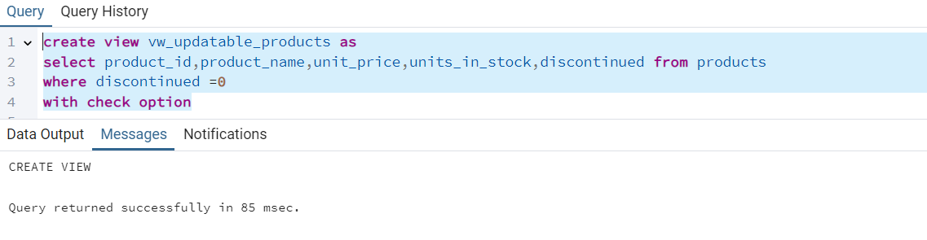

Update query:

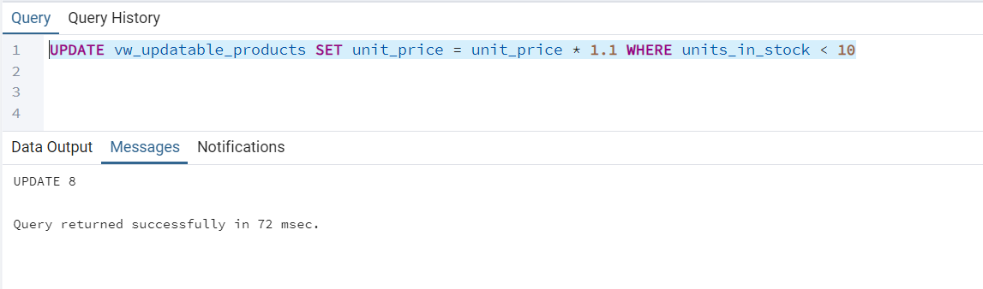

Select Query:

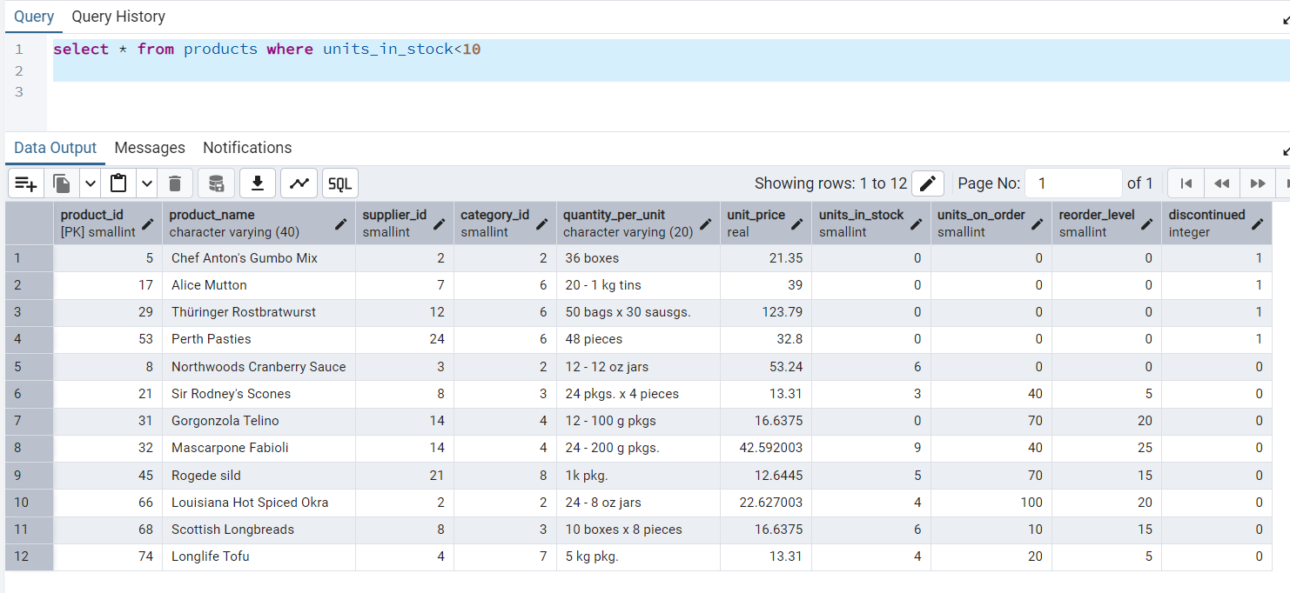

Select View:

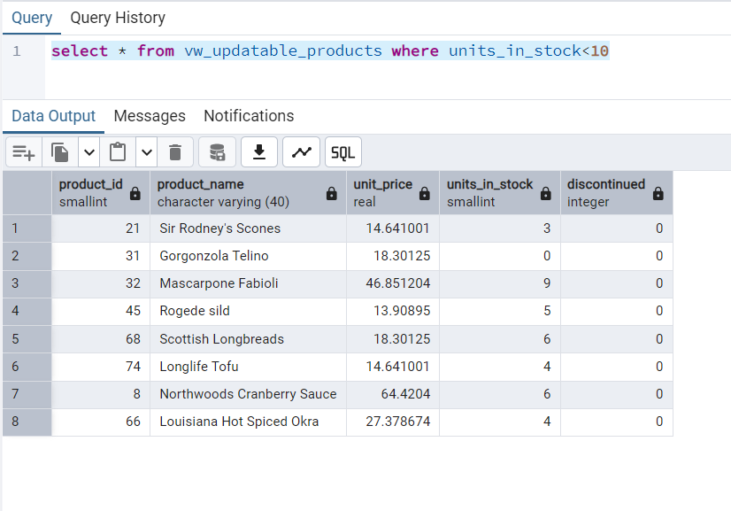

2. Transaction:

COMMIT:

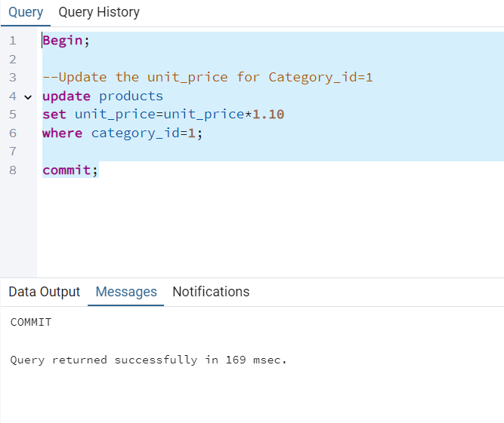

ROLLBACK:

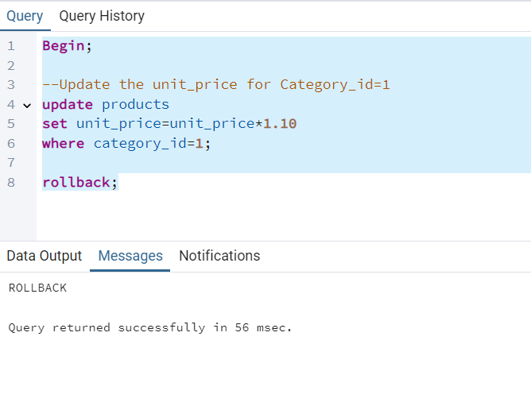

3.  Create a regular view which will have below details (Need to do joins):

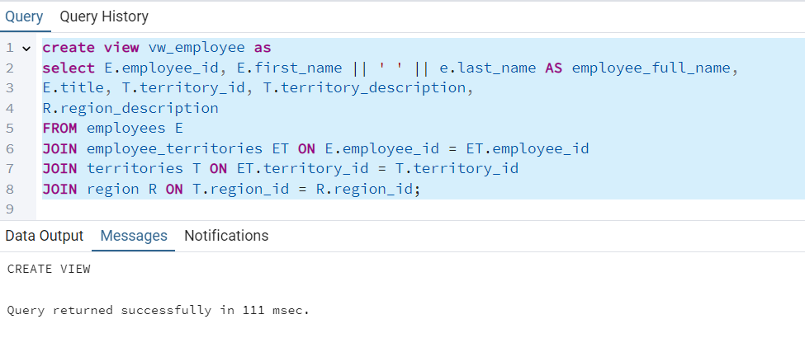

Select View:

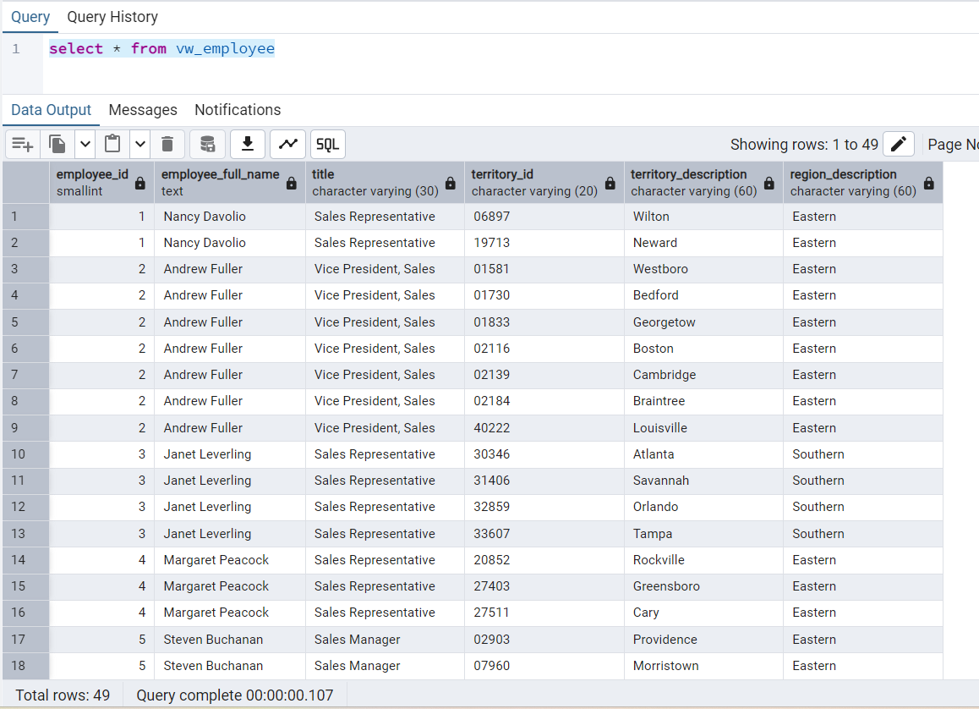

4. Create a recursive CTE based on Employee Hierarchy

